CHANNELING INTERNATIONAL MARKETS TO IMPROVE DOMESTIC SUCCESS
Narek Sahakyan, Michael W Nicholson and David Kritzberg

Abstract
This paper investigates potential links between the international and club-level soccer using a measure of quality defined by the performance of its club teams in international competitions. We address the inherent endogeneity by employing an instrumental variables approach, based on the urban population share of a country. Our identifying strategy assumes that the support for soccer clubs in metropolitan areas that drives club-level success affects national teams only through their impact on domestic professional players; being born a great athlete to a certain nationality still remains to chance. Using annual panel data from 1993 to 2010 for all FIFA countries, we isolate the impact of domestic club strength on national teams and demonstrate a positive impact on national team results. The converse should also hold, and our results thus suggest that the long decline of Brazilian club soccer played a salient role in the results for the 2014 World Cup host.

Keywords: Networks, Globalization, Panel Data Econometrics

Introduction
The Fédération Internationale de Football Association (“FIFA”) has more members than the United Nations. Despite the ubiquity of soccer fans and soccer talent throughout the global community, however, the highest quality soccer played on a weekly basis is constrained to a handful of European professional leagues. The best non-European players generally play in their own domestic leagues if, frankly, they can’t make the cut in Europe. Higher salaries in European leagues pull the best players to Europe, while corrupt or underdeveloped soccer institutions in their home countries, push the best players from South America and Africa to Europe. International competition, however, is increasing, and despite an all-Europe final in two of the past three World Cups, countries outside the “core” have been improving their lot. In their influential book Soccernomics, Kuper and Szymanski (2009) question the conventional wisdom that England’s failure on the international stage can be related to the increasing presence of foreign players in the English Premier League.
Do strong domestic leagues improve national team performance? The dominant clubs in Spain and Germany, the dominant national teams of the past decade, have enjoyed unprecedented success, with an all-German 2013 UEFA final and all-Spanish 2014 UEFA final. Is this a coincidence? At the time of its inception in 1996, Major League Soccer was intended as a domestic league for the United States to improve its national team performance following the 1994 World Cup. Has it worked?
This paper seeks to answer these questions by addressing potential links between a country’s soccer performance at the professional club and at the national level, using an aggregate measure of quality defined by the performance of its club teams in international competitions. We contribute to existing research on the determinants of national team performance by bringing club teams – the places where the majority of players spend the majority of their playing careers, and where fans display their passion weekly – to the center of the discussion. We construct an index for national soccer endowment, “CLUB” based on aggregate performance of the country’s club teams in international competitions. A critical feature of the CLUB variable is that teams are defined by their geographical location. Chelsea is an English club, whether it starts eleven players from England or none at all, and whether it is owned by a foreign billionaire, or run by a council of borough elders. For the purposes of this study, the effects of any club team are defined exclusively by their impacts on the national team. In extreme cases, the two can be synonymous. To correct for the inherent endogeneity between these national- and club-level soccer performance measures (FIFA and CLUB), we employ an instrumental variables approach, using two-stage least squares for panel data models (IV/2SLS). Our identification strategy assumes that the instrument for CLUB, the urban population of a country, affects the success of the national team solely through its impact on domestic professional players. Accounting for macro-economic and resource variables, CLUB has a positive and statistically significant impact on FIFA.
Another contribution of this paper is to model the relationship between soccer success and country-specific variables over time. We use FIFA Points, available on FIFA’s website to construct an annual time-series for all countries in the world, spanning from 1993 to 2010. This measure of international soccer success, FIFA, is then regressed on national income and resource measures using data from the World Bank’s World Development Indicators, using fixed-effects OLS models. To account for other time-varying factors, we then introduce additional dynamic policy- and resource-related variables and turn to analyzing the statistical relationships by confederation, to illustrate the varied effect of these factors in different parts of the world.
The rest of the paper is organized as follows. Drawing on existing literature, Section 2 provides a brief review and presents the data. Section 3 develops the econometric specifications and sets up the hypothesis tests with a focus on proper identification procedures. Section 4 provides results and Section 5 offers concluding thoughts.

- Literature and Data
The literature on the determinants of international football performance generally incorporates macroeconomic measures, geographic indicators, human development data, institution indices, and other non-economic factors typical of international trade theory that may explain long-term soccer success. In these largely empirical studies, World Cup performance or FIFA points are usually regressed on wealth measures and population using a cross-section of countries. These variables are generally found to be good predictors of international soccer success, in which just population and income can explain upwards of 50% of variability in FIFA rankings. However, in the top-20 list of FIFA rankings available since 1993, one can consistently find relatively smaller and middle-income European and South American countries, usually recognized by their strong soccer tradition. Seminal papers in this literature, such as Hoffman, Ging and Ramasamy (2002), among others, heavily rely on an indicator variable for whether a country is “Latin” to explain the success of countries like Uruguay and Argentina relative to the United States and China. Other “tradition” variables, such as hosting a World Cup, number of years in FIFA, having a FIFA president from the country are also included in similar empirical papers Torgler (2006, 2007).

Foer (2004, 2006) suggests three political determinants of success in world soccer: political regime, colonial heritage, and institutions. He predictions that colonizers beat former colonies and oil producers will underperform. He also predicts that dominant domestic clubs will not benefit national teams from EU countries due to player mobility. Cultural, political or institutional factors, such as centrally-planned economies or dictatorships tend to be associated with higher soccer performance at the international stage.
Each country’s collective preference for the sport of soccer raises the quality of its national side by shaping both the supply and the demand for quality play, by diverting available resources to the development of soccer, or some inherent cultural or even religious disposition towards the sport. National preference, like an invisible hand of the market, on one hand provides the supply, by encouraging the country’s most talented athletes to pursue a career in soccer over alternatives, and on the other - the demand, through the fans who purchase tickets and fill stadiums on a weekly basis . A country’s soccer endowment also shapes its national team, comprised of the selected eleven on the field, the team coach, and the bench. Guided by this joint preference for soccer, given the resource constraints, the team is continually tested and improved in international competition. Competitive outcomes determine the national team’s FIFA Points and thus its relative strength.
We distinguish three types of variables: (a) macroeconomic factors, (b) natural resources, and (c) soccer tradition (endowment). Table 1 summarizes the variables included in our models with a note of expected signs based on relevant cites in the existing literature. We obtained all the non-soccer data from the World Development Indicators, for a set of 200 countries, spanning from 1993 to 2010. These variables are matched with annual FIFA points, which are available for this time period from the FIFA website, and with Club rankings constructed from panel data, made available by Oosterpark Rankings.,
Table 1: Data summary and hypotheses
Variable | Label | Expected Positive Effect | Expected Negative Effect
a. Macroeconomic factors
GDP Per Capita (thousands) | GDP | Hoffman, Ging, Ramasamy (2002)  Houston and Wilson (2002)  Torgler (2004, 2008)  De Bosscher, et al. (2006)
GDP Per Capita (thousands) Squared | GDP ² |  | Hoffman, Ging, Ramasamy(2002)  Houston and Wilson (2002)  Torgler (2007)
Trade as% of GDP | TRADE | Milanovic (2004)  Baur and Lehmann (2007)
Inflation, consumer prices | INFL | - | -
b. Resources / Infrastructure
Oil Rents as % of GDP | OIL | Leeds and Leeds (2009)  Luiz and Fadal (2010) | Foer (2004, 2006)
Population (millions) | POP | Macmillan and Smith (2007)  Torgler (2007)
Population (millions) squared | POP ² |  | Macmillan and Smith (2007)
Life expectancy at birth | LEB | Kavetsos and Szymanksi (2008)
Urban population as % of total | UrbPOP | Kuper and Szymanski (2009)
c. Tradition / Endowment
Host of World Cup, years in FIFA,  FIFA president | - | Torgler (2004, 2008)
Latin American culture | - | Hoffman, Ging, and Ramasamy (2002)  Torgler (2007)
Domestic league quality / success | CLUB | Foer (2004)  Leeds and Leeds (2009)

Macroeconomic factors
GDP per capita.We expect the coefficient on GDP per capita to be positive. The empirical literature finds, unilaterally, a strong positive relationship between soccer success and national wealth measures. Following Hoffman, Ging, Ramasamy (2002), Houston and Wilson (2002), and Torgler (2004, 2007, 2008), we include a quadratic term control for non-linear effects of wealth and expect a negative sign for the coefficient of the quadratic income term, pointing towards diminishing returns of income on football success. Torgler (2008) does not find the inverted-U relationship with GDP per capita with respect to women’s FIFA success -- the four largest economies in the world (United States, China, Japan, and Germany) also field the four best women’s teams.
Trade as a percentage of GDP. We use trade as a percentage of GDP as a measure of exposure of the country to global trading markets, as suggested by Milanovic (2004). This variable is often characterized in the trade literature as a proxy for “openness”, with an expected positive sign because more “open” countries have easier access to the best soccer know-how and talent, while more “closed” economies are isolated from the global community and are thus behind the learning curve. Kuper and Szymanski (2009) point to the success of countries that are able to efficiently absorb and create a perfected, hybrid style of play.
Inflation. Inflation is included as a proxy of national macro-fiscal stability and health. While economic literature does not provide unequivocal evidence on adverse effects of high inflation rates on a country’s economy, sustained periods of high inflation and economic shocks caused by currency changes, which are recorded as hyper-inflation in WDI data, are generally red flags for economic uncertainly and volatility.

Resources / Infrastructure
Population. We expect a positive sign on population. A country’s population is a direct measure of the available talent pool. Countries that have access to a larger pool of talent should do better at producing high quality national teams. Similar to the national income variables, there is some evidence, as provided by Macmillan and Smith (2007) that higher population contributes to soccer success at a diminishing rate. To account for this non-linear relationship between population and soccer success, we include a quadratic term, which we expect to be negative.
Oil rents as a percent of GDP. Using 2006 cross-country data, Leeds and Leeds (2009) analyze the predictions of Foer (2004) by incorporating the following variables: Communist dummy, Freedom House Index, OECD dummy, colonial dummies, colonizer dummies, oil quantitative variable, and institutional proxies (host dummy, year dummy). Contrary to two of Foer’s three “iron laws”, Leeds and Leeds (2009) find that oil producing countries do not underperform, and that having a strong domestic league helps performance at the national level, concluding that "either oil-rich countries provide much financial support for soccer, or oil-induced malaise does not filter down to soccer performance." We do not hold a priori expectations regarding the sign of the coefficient for OIL.
Life expectancy at birth. We expect a positive sign, as healthier nations with higher quality of life should be able to produce better athletes. Kavetsos and Szymanksi (2008) investigate the impact of international sports events, such as the Olympics, World Cup, and UEFA championship on national wellbeing. Following this focus on general national prosperity, we include elements of the Human Development Index (HDI) as a measure of soccer capacity. Due to the lack of pre-2005 longitudinal HDI data, we are forced to rely on per capita income and life expectancy at birth data obtained from the World Bank’s World Development Indicators.
Urban population. Percent of urban population is the instrument we use to identify the simultaneous relationship between national- and club-level measures FIFA and CLUB, which is discussed at more detail in the next section. To account for possible diminishing returns, we also include a quadratic term. Kuper and Szymanski (2009) provide an extensive discussion on the connections between large industrial towns and successful club teams. Since higher CLUB indicates countries with lower quality club teams, and therefore lower soccer endowment, we except a negative, and statistically significant (for proper identification) coefficient for urban population.

Soccer tradition / Endowment
CLUB. Stronger domestic club teams are a product of higher national soccer endowment and will correlate with higher performance at the international stage. Any rank measure is inversely related to a point measure, therefore we expect a negative sign in CLUB rank reflect its inverse relationship with nation’s accumulated FIFA points.
Torgler (2007) analyzes the historical performance of countries in World Cup tournaments for the period of 1930 to 2002 and finds that popularity and tradition, as measured by membership in FIFA and having previously hosted a World Cup, have a big impact on World Cup success. He follows Hoffman, Ging, Ramasamy by including temperature and population as predictors of World Cup success. Similar to Houston and Wilson (2002), Torgler (2007) finds increasing, but diminishing marginal returns to income. Torgler re-introduces Hoffman, Ging, Ramasamy’s LATIN variable, interacts it with population, and finds that this measure of “Latin-populated-ness” is a good predictor of football success. To make sure it is just the cultural component of the LATIN variable that is driving the statistical significance, Torgler (2007) then includes an income inequality measure, which is found to be insignificant, while “Latin-populated-ness” remains statistically significant.
While including dummy variables reflecting geographic, cultural and political factors may provide interesting insights about the correlations between national soccer success and such variables, the CLUB variable effectively captures the dynamic components of such factors underlying the soccer endowment of the country. Furthermore, as the fixed-effects model employed in the estimation focuses only on the time-varying effect of covariates (i.e. the within-country variation), all time-invariant characteristics are picked up by the country fixed effects, thereby reducing any bias resulting from imperfect measurement or unobserved heterogeneity. Therefore, other country-specific time-invariant variables, such as temperatures, humidity, land area and latitude, as discussed in the empirical literature, are also controlled for via the country fixed-effect.
Tables A-1 and A-2 in the appendix present descriptive statistics alongside national- and club-level rankings for the top and bottom tiers of FIFA and European countries. The figures are presented for 18-year averages, spanning the period from 1993 to 2010. The countries are sorted by national strength, calculated by averaging annual FIFA rankings over the 18-year period. As a reference point, for each subgroup, maximum, mean and minimum figures for all the variables across the 18-year period are given in the top, middle and bottom rows of the tables. Guided by the data summary provided in Table 1, in the top halves in Tables A-1 and A-2 we should look for countries with relatively higher club ranking (CLUB), per capita income (GDP) and population (POP). These countries should also be more “open” (TRADE), have higher life expectancy at birth (LEB) and lower inflation (INFL). Higher percent of urban population (UrbPOP) should be accompanied with higher club rating (CLUB).
As the top half of Table A-1 clearly illustrates, throughout the last two decades European nations have dominated the international football stage. Out of the top 15 FIFA counties, ten are European, three are South American and two are from North America. There is a strong connection between FIFA and Club Rank evident from comparing the first two columns of Tables A-1 and A-2.
Furthermore, a side-by-side comparison of economic indicators of top soccer nations illustrates clear differences in the way countries utilize their resources to build teams. First, Brazil is quite special. The undisputed leader over the last two decades has an average GDP per capita of $7,800, which is the lowest in our top -15 list and about three times lower than the per-capita income of the subsequent three countries in the list. It is also the least “open”, has the highest average inflation rate and second worst life expectancy in the top-15. Brazil’s secret? Its very large and relatively urban population cares about soccer very, very much. The CLUB rank variable reflects this quite well. In fact, all three South American countries that are among the top 15, along with Mexico (and Russia), have wealth measures similar to the sample country average. However, these countries compensate for this lack of wealth with their relatively large and urbanized populations, which respectfully contribute to national success, directly through access to a larger talent pool, and indirectly through higher soccer endowment, as is reflected in their relatively higher club-level rankings.
Therefore, income and population matter, but to restrict the factors of international soccer success to wealth and population would be naïve. The United States is another “special” country with respect to the discrepancy between its resources and soccer achievements. Among the countries in our top-15 list, the United States is rated second from the bottom yet features the highest income per capita and highest population of these fifteen countries. Comparing the United States to Denmark, a country adjacent in the rankings to the US, with similar soccer achievements at both the international and the club level, provides for an interesting story.Danes and Americans live under very comparable (and comfortable) economic conditions: Americans receive an extra $6,600 per year in income, both have experienced identical levels of inflation, and both Danish and American babies born between 1993-2010 can expect to live about 77 years. Even with an (arguably) “more closed” economy, it would seem that with a population size of about 53 times that of Denmark, the United States should do a lot better. As Soccernomics puts it, “If only Americans took soccer seriously, the country’s fabulous wealth and enormous population would translate into dominance.”

- Econometric specification and identification
Given that some of the same players simultaneously represent both club teams and national teams, any econometric specification among their relative determinants must accommodate this inherent endogeneity. With the exception of Brazil, the same large, rich countries that traditionally host the strongest club leagues employing the highest quality players (Germany, Italy, Spain, England) also have realized extended success at the national level. This section develops an econometric specification to isolate the club effect from the national effect and outlines our identification assumption.
Three separate estimating equations of increasing complexity develop systematically our innovative approach. Equation 1 provides a baseline measure of the dynamic impacts of national wealth and population. Including GDP (per capita) and population, along with the quadratic terms in this specification, allows us to test the results of Hoffman, Ging, Ramasamy(2002) and Houston and Wilson (2002), among others, in a dynamic setting, over the 18-year period of time:
FIFA = f(GDP, GDP² ; POP, POP²) (1)
The second estimating equation expands on the basic wealth and population measures, to include proxies for the other selected determinants of international soccer success.
FIFA = f(GDP, GDP², POP, POP² ; TRADE, INFL, OIL, LEB) (2)
These two equations lend themselves to a comparison of the determinants across the FIFA regions, to help identify why Europe and South America appear to be “special”. Finally, the third estimating equation incorporates the measure of aggregate domestic league strength - CLUB, as a proxy for national soccer endowment.
FIFA = f(GDP, GDP², POP, POP²; TRADE, INFL, OIL, LEB; CLUB) (3)
Statistical estimation of (3), however, is complicated by the above-discussed endogenous relationship between FIFA and CLUB. Both FIFA and CLUB are determined by the outcomes of specific matches, and therefore, at the most basic level, the outfield performance of the players. The performance of the players, in its turn, depends on their inherent ability, alongside some other unobservable factors, which may best be measured by their placement with prestigious clubs and success in competitions. The more players with a high-quality club/ league affiliation a country’s national team has, the more likely it will achieve success in international matches. This effect will be even stronger when the “high-quality” league/club coincides with that country’s own domestic league, such as in Spain, Germany, England Italy and France..
For a given country, an increase in club team strength will affect national team strength directly and indirectly: directly due to a higher proportion of high-quality (local) players the managers can pick from; and indirectly due to the intensity of soccer competition in the country. It can be argued, however, that successful performance by players of a certain national team at a global stage like the World Cup will signal ability, and have an effect on the placement of high-ability players in successful and high-performing clubs of potentially any country, usually hosting a high-quality league.
If club teams could employ only local players, we would expect an almost perfect correlation between club success (CLUB) and national success (FIFA). Conversely, in the autarky scenario, in which players performed only for their own nation’s domestic club teams, a country’s international club success would mirror its national success: the sum of points scored by domestic clubs against foreign clubs should roughly sum up to the national team points scored against foreign national teams. However, the free migration and trade of players complicates this relationship.
Furthermore, many of the conditions that give rise to strong national teams, most notably wealth and population, may also lead to strong club teams. Due to these implications, equation (3) suffers from identification as a statistical model, as CLUB is itself a function of the macro and resource variables. To overcome this challenge we consider the element of country’s urban population.
National teams draw on a fan base from the entire country. Professional clubs, however, depend on attendance and a stronger local fan base for survival, which manifests itself in denser urban areas.Any relationship between urban population and national team success, as opposed to local club support, will be transmitted through the club success. If denser populations lead to stronger club leagues or increase the efficiency of talented players, these players will be developed at the club level and gradually filter up through stronger clubs before arriving fully-formed on the international stage. Therefore, the identifying assumption for (3) is that country’s percent of urban population is not correlated with football success at the national level, (i.e. the higher FIFA rankings) through channels other than its effect on the country’s club strength. Post-estimation identification statistics (presented in Appendix A-3) confirm that the equation is exactly identified.To account for potential non-linearity in the relationship between urban population and CLUB, we include a quadratic term. The final estimating system of equations therefore becomes:

  - FIFA = f(GDP, GDP², POP, POP²; TRADE, INFL, LEB, OIL;CLUB)

  - CLUB= g(GDP, GDP², POP, POP²; TRADE, INFL, LEB, OIL; UrbPOP, UrbPOP²).

Results
In this section we present the results of estimation of equations (1), (2) and (3.1-3.2). For all models and regional confederations, there is a strong correlation (greater than 0.90) between the country-specific residuals and predicted outcomes. This is evidence that our choice of fixed-effects versus random-effects as the appropriate model for econometric estimation is supported by the data. Equations (1) and (2) are estimated using cluster-adjusted robust standard errors. System of equations (3.1-3.2) is estimated using cluster-adjusted and autocorrelation-robust standard errors.
Table 2: Results of equation (1) by regional confederation
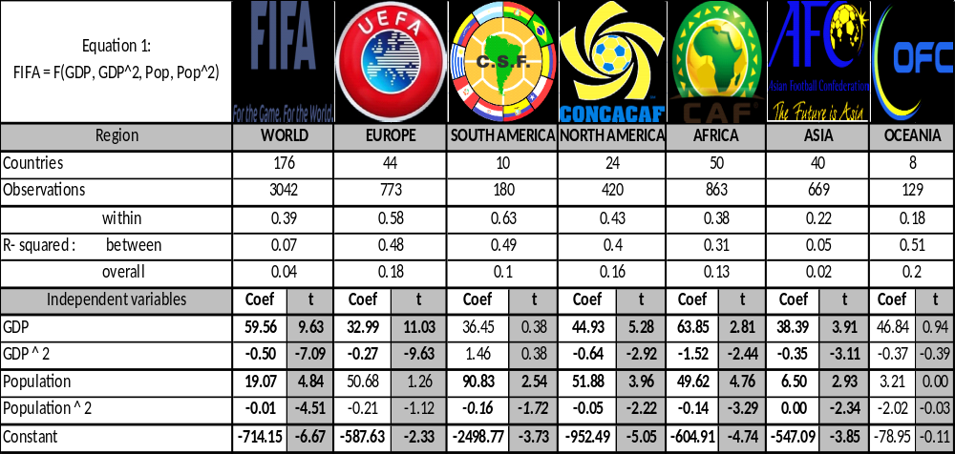
Notes: Bold indicates statistical significance at 5%. Oceania is excluded due to insufficient number of valid observations. Source: Authors’ calculations.

Equation (1)
Table 2 provides results for the full panel for equation (1) for 176 countries from 1993 to 2010 with estimates consistent with Hoffman, Ging, Ramasamy (2002) and Houston and Wilson (2002). Estimation results suggest that a quadratic relationship does exist between national wealth (GDP per capita) and international soccer success (FIFA points.) Countries tend to do better on the pitch as they get richer, up to a certain critical mass of wealth, after which the returns to per capita income are negative. Consistent with Macmillan and Smith (2007), similar diminishing returns are expected, and found, with respect to population.
A notable exception to this rule is South America. Consistent with our discussion in Chapter 2, as well as the empirical evidence provided in Appendix A-1, regression results also point out that national income is not the main driver of soccer success here. Given the relative weight of soccer powerhouse Brazil and its relatively low per capita national income, this result is not unexpected. Similarly, while the coefficients of population have the expected signs for the European countries, they are statistically insignificant.
Summarizing, the results of estimation of equation 1 reveal positive-diminishing effects of GDP and POP on international soccer performance for the entire sample, and for the regional confederations individually.

Equation (2)
Table 3 presents results of equation (2) using the full complement of explanatory variables regarding the determinants of FIFA success.
Table 3: Results of equation (2) by regional confederation
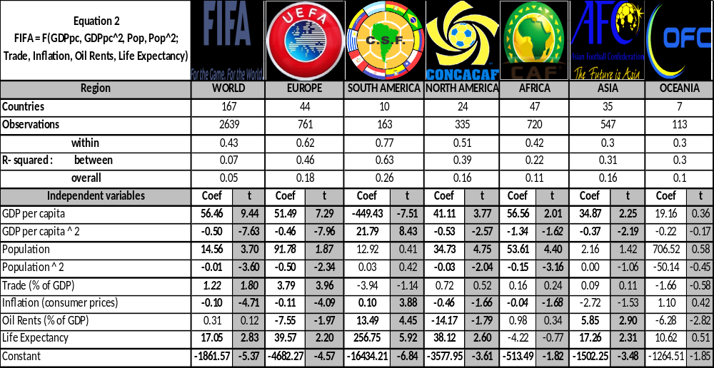
Notes: Bold and bold-italicindicate statistical significance at 5% and 10%, respectively. Oceania is excluded due to insufficient number of valid observations. Source: Authors’ calculations.

Additional economic and resource variables included in Equation 2 generally have the expected signs and are statistically significant for the whole dataset (FIFA) and for the majority of regions. Most importantly, the signs of coefficients of GDP and POP, along with their respective quadratic terms, remain largely consistent with the findings from previous empirical studies. An exception to the “income and population rule” is South America again, where higher GDP seems to go with lower international soccer success, while the POP coefficients have the expected signs, but are statistically insignificant. Note that the statistical significance of key variables is generally lower for countries in Asia and Africa, due in part to data availability. This issue is more severe for Oceania, which has been excluded from the table due to insufficient number of observations to generate any statistical precision.
The differences between the results of countries in European and South American confederations outline an interesting story, at the heart of which is the balance between available resources and footballing tradition, as well as the migration of South American talent to European leagues. Given the small number of available observations and countries in the South American sample (10 countries with 163 observations), as well as the extreme relative weight of the few nations within this subgroup, it is very likely that the observed negative income effects are driven by relatively GDP-hindered Brazil.
The coefficients for TRADE are positive and statistically significant at the 5% level for the European sample, and at the 10% for the FIFA sample. TRADE has the expected sign for all but the South American confederation, where, as Table A-1 in the appendix shows, the top three CONMEBOL countries in terms of international soccer success are the ones that are least “open”.
Other notable differences stand out when comparing the coefficients of individual regions, particularly those of Europe and South America. The negative sign of the OIL coefficient seems to indicate that European oil producers are suffering from a case of the “resource curse”, while in South America, (and to a lesser degree in Asia) a relatively higher proportion of OIL is perhaps diverted into the soccer infrastructure, thereby resulting in an estimated positive coefficient. The coefficient for OIL is positive, but does not seem to have a statistically significant effect on soccer achievements of African countries, or when considered for the whole FIFA sample.
Higher inflation rates accompany lower soccer outcomes for the whole FIFA sample and in European countries at the 5%, and for North America and Africa at the 10% significance level. Brazilian soccer, on the other hand, does not seem to be negatively affected by the high levels of INFL in the country, as reflected by the positive and statistically significant coefficient estimated for this variable for South American countries.
Finally, the coefficient for LEB is positive and statistically significant for all, but African countries. The coefficient is an order of magnitude larger for countries in South America, indicating that these countries would benefit the most from higher national health.
In sum, estimation results presented in Table 3 indicate that while the variables included in Equation 2 as determinants of international soccer performance are consistent with the existing, their effect is varied, and in some cases orthogonal in different regions of the world.

Equation (3)
Table 4 provides results for equation (3) using the instrumental variable technique defined in (3.1) and (3.2). All economic and resource variables are assumed exogenous on FIFA. CLUB is endogenous and is instrumented with UrbPOP (and UrbPOP²), which is expected to be positively correlated with club strength but not (directly) with FIFA.Again, note that a higher CLUB ranking is associated with a lower value (being No. 1 is better than being No. 2) and thus a negative coefficient on the variable is associated with a positive impact on FIFA. We present regression results for two sets of countries – the full sample (FIFA) and the European subgroup (UEFA).

Table 4: Results of equation (3) for FIFA and UEFA

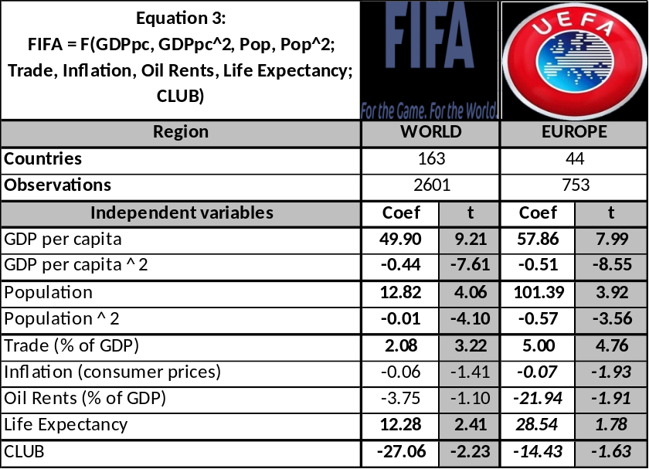
Notes: Bold and bold-italic indicate statistical significance at 5% and 10%, respectively.
Source: Authors’ calculations.

A seminal result of this paper, the endogenous variable CLUB is statistically significant at the 5% level for the whole FIFA sample, and at the 10% level for the UEFA subgroup. Its effect is about twice smaller for UEFA subgroup, compared to that of the whole sample, in line with Foer’s (2006) position that strength of domestic leagues will have a weaker effect in Europe due to more intensive player trade.
With the exception of INFL and OIL, both for FIFA and UEFA samples, all of the coefficients have the expected signs and are statistically significant at least at the 10% level. Precisely estimated and strong positive-diminishing returns from GDP and POP persist for both FIFA and UEFA.
Economic “openness”, as measured by TRADE, has a positive impact on international soccer achievements. European countries benefit from TRADE about 2.5 times more than an average country in the FIFA sample.
OIL rents are negatively correlated with soccer success both for the full sample and for Europe, but are statistically significant only for the set of European countries. Ignoring the imprecision of the OIL coefficient estimate for the FIFA sample, the negative impact of OIL rents is about seven times larger in Europe.
The magnitude of this negative correlation is approximately of the same order as the positive impact of LEB. So for example, for the countries in the UEFA subgroup, losses in international soccer success associated with a one percent increase in OIL rents should be more than offset by a one-year increase in life expectancy at birth, or a four percent increase in TRADE. Similarly, a one-year increase in LEB translates to about the same amount of gain in predicted FIFA points as country’s advancement by two positions in CLUBrankings.

Conclusions
This paper finds that strong domestic club teams have significant benefits for the national soccer team. Using a two-stage regression that incorporates the urban population of a country to isolate the impact of club success on national team success, we provide statistical evidence that a stronger domestic league positively affects national team performance. In a specific example, the results suggest that the U.S. Soccer team benefited from the presence of both one of its better national team players, Landon Donovan, and one of the better English players, David Beckham, on the U.S. domestic club LA Galaxy. The stronger the domestic club league, MLS, the better should be the U.S. national team.
Other major results of this paper provide further support for certain empirical rigidities in the relevant literature. With a few notable exceptions, like the United States and China, the larger, richer countries generally perform best at soccer. Countries with better living conditions, as proxied by life expectancy at birth, also generally perform better on the pitch. Access to international networks, as measured by the trade “openness”, has a positive impact in Europe. This is less the case for FIFA overall, mainly due to the exceptional performance of teams from South America. Higher dependence on oil rents is associated with lower soccer outcomes in Europe and North America, and conversely, with higher soccer success in South America.
The results highlight the internal logic that the best players in the world (e.g., Lionel Messi) play for the best clubs (e.g., FC Barcelona), which feed the best national teams (e.g., Spain), leading to their conspicuous international success over the past decade. These same findings also support Foer’s (2004) description of Brazilian clubs as corrupt and downtrodden, leading the Canarinho to disappointing performance as hosts of the 2014 World Cup.
References
Baur, D. and Lehmann S. “Does the Mobility of Football Players Influence the Success of the National Team?” Institute for International Integration Studies,2007, IIIS Discussion Paper No. 217.
De Bosscher, Veerle, De Knop, van Bottenburg, and Shibli, S. “A Conceptual Framework for Analysing Sports Policy Factors Leading to International Sporting Success.” European Sport Management Quarterly,2006.
Foer, F. “How Soccer Explains the World: An Unlikely Theory of Globalization.” New York, HarperCollins, 2004.
Foer, F. “How governments nurture soccer.” The New Republic, posted June 19, 2006.
Hoffman, R., GingL. and Ramasamy, B. “The Socio-Economic Determinants of International Soccer Performance.” Journal of Applied Economics, 2002, 5(2): 253-272.
Houston, R., and Wilson, D. “Income, Leisure, and Proficiency: An Economic Study of Football Performance.” Applied Economic Letters, 2002, 9:939-943.
Kavetsos, G. and Szymanksi, S. “National Wellbeing and International Sports Events.” North American Association of Sports Economists Working Paper Series, 2008, Paper No. 08-04.
Kuper, S. and Szymanksi, S.“Soccernomics: Why England Loses, Why Germany and Brazil Win, and Why the U.S., Japan, Australia, Turkey – and Even Iraq – Are Destined to Become Kings of the World’s Most Popular Sport.” Nation Books, 2009.
Leeds, M. and Leeds, E. “International Success and National Institutions.” Journal of Sports Economics,2009, 10(4): 369-390.
Luiz, J. and Fadal, R.,“An Economic Analysis of Sports Performance in Africa.” Working Paper No. 162. Wits Business School, Witwatersrand, 2010.
Macmillan, P. and Smith, I. “Explaining International Soccer Success and National Institutions.” International Association of Sports Economists,2007, Working Paper No. 0702.
Milanovic, B. “Globalization and Goals: Does soccer show the way?” Review of International Political Economy, 2006, 12(5): 829-850.
Nicholson, M. “The Impact of Tax Regimes on International Trade Patterns.” Contemporary Economic Policy, 2012, 30(3): 1-16.
PriceWaterhouseCoopers, “What can econometrics tell us about World Cup performance.”, May 2010, http://www.ukmediacentre.pwc.com/News-Releases/Power-v-passion-Wealth-comes-second-to-location-and-tradition-when-projecting-World-Cup-winners-e94.aspx
Schaffer, M.E.“xtivreg2: Stata module to perform extended IV/2SLS, GMM and AC/HAC, LIML and k-class regression for panel data models.” IDEAS, 2010. http://ideas.repec.org/c/boc/bocode/s456501.html
Torgler, B. “The Economics of the FIFA Football World Cup.” Kyklos, 2004, 57: 287-300.
Torgler, B. “What shapes player performance in soccer? Empirical findings from a panel analysis.” Applied Economics, 2007, 39: 2355-2369.
Torgler, B. “The Determinants of Women’s International Soccer Performances.” International Journal of Sports Management and Marketing, 2008, 3(4): 305-318.
Yamamura E. “Effect of Linguistic Heterogeneity on Technology Transfer: An Economic Study of FIFA Football Rankings.” 2008, Mimeo, http://mpra.ub.uni-muenchen.de/10305/.
Abbreviations:

AFC - Asian Football Confederation
CAF - Confederation of African Football
CONCACAF - Confederation of North, Central American and Caribbean Association Football
CONMEBOL – CONfederación SudaMEricana de FútBOL
FIFA – Fédération Internationale de Football Association
GDP – Gross Domestic Product
HDI – Human Development Index
OFC - Oceania Football Confederation
UEFA - Union of European Football Association
WDI – World Development Indicators

APPENDIX 1

Descriptive statistics for top and bottom 15 FIFA countries in terms of average FIFA ranking (1993-2010)
 | Country | FIFA Rank | Club Rank | GDP Per Capita | Trade % GDP | Inflation | Oil%GDP | Population | Life Exp | %Urban | Confed.
 | MAXIMUM (FIFA) | 2 | 3 | 70 | 372 | 463 | 62 | 1269.10 | 81.3 | 100.0 | Confed.
1 | Brazil | 2 | 3 | 7.8 | 22 | 232 | 2 | 177.2 | 70.5 | 81.9 | CONMEBOL
2 | Spain | 5 | 5 | 23.6 | 53 | 3 | 0 | 41.9 | 79.5 | 76.5 | UEFA
3 | Germany | 6 | 8 | 28.3 | 67 | 2 | 0 | 82.1 | 78.1 | 73.3 | UEFA
4 | France | 7 | 10 | 26.6 | 51 | 2 | 0 | 61.7 | 79.3 | 76.1 | UEFA
5 | Argentina | 7 | 3 | 10.3 | 31 | 6 | 3 | 37.4 | 74.0 | 90.4 | CONMEBOL
6 | Italy | 7 | 5 | 26.5 | 50 | 3 | 0 | 57.9 | 79.7 | 67.4 | UEFA
7 | Netherlands | 8 | 17 | 31.0 | 126 | 2 | 0 | 16.0 | 78.6 | 77.5 | UEFA
8 | England | 10 | 7 | 27.8 | 56 | 2 | 1 | 59.5 | 78.2 | 89.5 | UEFA
9 | Czech Republic | 11 | 48 | 18.0 | 128 | 5 | 0 | 10.3 | 75.3 | 73.9 | UEFA
10 | Mexico | 13 | 11 | 10.2 | 56 | 11 | 5 | 101.6 | 74.5 | 75.2 | CONCACAF
11 | Portugal | 14 | 16 | 18.8 | 65 | 3 | 0 | 10.3 | 76.8 | 55.3 | UEFA
12 | Chile | 15 | 11 | 15.8 | 71 | 1 | 0 | 17.1 | 78.9 | 89.0 | CONMEBOL
13 | Denmark | 17 | 34 | 30.3 | 85 | 2 | 1 | 5.4 | 76.9 | 85.6 | UEFA
14 | United States | 19 | 38 | 36.9 | 25 | 2 | 0 | 285.5 | 76.9 | 79.5 | CONCACAF
15 | Russia | 19 | 19 | 10.3 | 56 | 95 | 13 | 145.1 | 66.2 | 73.2 | UEFA
 | MEAN (FIFA) | 92 | 63 | 11 | 88 | 21 | 5 | 36.57 | 67.6 | 54.7
186 | Seychelles | 168 | 80 | 18.0 | 198 | 9 | 0 | 0.1 | 72.4 | 52.9 | CAF
187 | Guyana | 171 | 84 | 2.2 | 204 | 6 | 0 | 0.7 | 64.6 | 28.6 | CONCACAF
188 | Philippines | 174 | 83 | 2.7 | 90 | 6 | 0 | 79.8 | 67.0 | 59.6 | AFC
189 | Samoa | 175 | 83 | 3.4 | 92 | 5 | 0 | 0.2 | 70.3 | 22.3 | OFC
190 | Cambodia | 175 | 83 | 1.3 | 111 | 6 | 0 | 12.8 | 58.9 | 18.4 | AFC
191 | Papua New Guinea | 176 | 83 | 1.8 | 122 | 9 | 13 | 5.6 | 59.4 | 13.1 | OFC
192 | Tonga | 179 | 83 | 3.8 | 71 | 6 | 0 | 0.1 | 71.2 | 23.8 | OFC
193 | Belize | 181 | 84 | 5.3 | 116 | 2 | 0 | 0.3 | 74.0 | 49.0 | CONCACAF
194 | Macau | 181 | 84 | 31.5 | 155 | 3 | 0 | 0.5 | 78.8 | 100.0 | AFC
195 | Central African Rep. | 182 | 84 | 0.7 | 38 | 5 | 0 | 3.8 | 45.0 | 37.8 | CAF
196 | Bahamas | 182 | 82 | 30.3 | 90 | 2 | 0 | 0.3 | 73.3 | 83.0 | CONCACAF
197 | Brunei Darussalam | 182 | 80 | 44.8 | 106 | 1 | 26 | 0.3 | 76.2 | 71.3 | AFC
198 | Mongolia | 186 | 82 | 2.8 | 117 | 9 | 1 | 2.5 | 65.3 | 56.9 | AFC
199 | Afghanistan | 189 | 81 | 1.0 | 79 | 9 | 0 | 32.1 | 47.4 | 23.9 | AFC
200 | Djibouti | 194 | 80 | 1.8 | 96 | 3 | 0 | 0.8 | 55.2 | 85.5 | CAF
 | MINIMUM (FIFA) | 194 | 87 | 0.3 | 1 | -0.3 | 0 | 0.04 | 44.1 | 8.2
APPENDIX 2
Descriptive statistics for top and bottom 15 UEFA countries in terms of average FIFA ranking (1993-2010)
 | Country | FIFA Rank | Club Rank | GDP Per Capita | Trade % GDP | Inflation | Oil % GDP | Population | Life Expectancy | % Urban
 | MAXIMUM(UEFA) | 5 | 5 | 59.3 | 258 | 349 | 38 | 145.1 | 80.2 | 97.1
1 | Spain | 5 | 5 | 23.6 | 53 | 3 | 0 | 41.9 | 79.5 | 76.5
2 | Germany | 6 | 8 | 28.3 | 67 | 2 | 0 | 82.1 | 78.1 | 73.3
3 | France | 7 | 10 | 26.6 | 51 | 2 | 0 | 61.7 | 79.3 | 76.1
4 | Italy | 7 | 5 | 26.5 | 50 | 3 | 0 | 57.9 | 79.7 | 67.4
5 | Netherlands | 8 | 17 | 31.0 | 126 | 2 | 0 | 16.0 | 78.6 | 77.5
6 | England | 10 | 7 | 27.8 | 56 | 2 | 1 | 59.5 | 78.2 | 89.5
7 | Czech Republic | 11 | 48 | 18.0 | 128 | 5 | 0 | 10.3 | 75.3 | 73.9
8 | Portugal | 14 | 16 | 18.8 | 65 | 3 | 0 | 10.3 | 76.8 | 55.3
9 | Denmark | 17 | 34 | 30.3 | 85 | 2 | 1 | 5.4 | 76.9 | 85.6
10 | Russia | 19 | 19 | 10.3 | 56 | 95 | 13 | 145.1 | 66.2 | 73.2
11 | Sweden | 19 | 47 | 29.4 | 83 | 1 | 0 | 9.0 | 79.9 | 84.1
12 | Romania | 20 | 39 | 8.3 | 67 | 50 | 2 | 22.1 | 71.1 | 53.9
13 | Norway | 24 | 40 | 38.9 | 72 | 2 | 11 | 4.5 | 79.1 | 76.0
14 | Croatia | 26 | 84 | 13.0 | 87 | 92 | 1 | 4.5 | 74.0 | 56.0
15 | Turkey | 28 | 28 | 9.7 | 47 | 46 | 0 | 64.9 | 69.9 | 65.4
 | MEAN (UEFA) | 54 | 52 | 18.9 | 94 | 37 | 2 | 21.0 | 74.8 | 68.6
34 | Latvia | 74 | 68 | 10.4 | 100 | 14 | 0 | 2.4 | 70.2 | 68.3
35 | Wales | 75 | 83 | 27.8 | 56 | 2 | 1 | 59.5 | 78.2 | 89.5
36 | FYR Macedonia | 78 | 78 | 7.1 | 99 | 10 | 0 | 2.0 | 73.3 | 63.9
37 | Cyprus | 79 | 36 | 21.8 | 100 | 3 | 0 | 1.0 | 78.1 | 68.9
38 | Georgia | 85 | 71 | 3.1 | 72 | 19 | 0 | 4.4 | 72.0 | 52.9
39 | Belarus | 86 | 71 | 7.1 | 128 | 277 | 2 | 9.9 | 69.0 | 70.7
40 | Albania | 91 | 82 | 5.1 | 64 | 12 | 2 | 3.1 | 74.5 | 42.8
41 | Estonia | 94 | 83 | 12.8 | 150 | 14 | 0 | 1.4 | 71.0 | 69.6
42 | Moldova | 101 | 69 | 2.1 | 128 | 15 | 0 | 3.6 | 67.5 | 43.7
43 | Armenia | 104 | 82 | 3.2 | 74 | 277 | 0 | 3.1 | 71.5 | 64.9
44 | Azerbaijan | 118 | 77 | 4.2 | 87 | 127 | 38 | 8.2 | 67.6 | 51.7
45 | Malta | 123 | 81 | 19.2 | 171 | 3 | 0 | 0.4 | 78.3 | 92.7
46 | Kazakhstan | 130 | 75 | 7.0 | 86 | 131 | 21 | 15.4 | 65.9 | 56.8
47 | Luxembourg | 137 | 82 | 59.3 | 258 | 2 | 0 | 0.4 | 78.2 | 82.9
48 | Tajikistan | 145 | 70 | 1.6 | 104 | 14 | 0 | 6.5 | 65.7 | 26.5
 | MINIMUM (UEFA) | 145 | 84 | 1.6 | 46 | 1 | 0 | 0.4 | 65.7 | 26.4

APPENDIX 3:
Post-estimation identification statistics and robustness checks
First Stage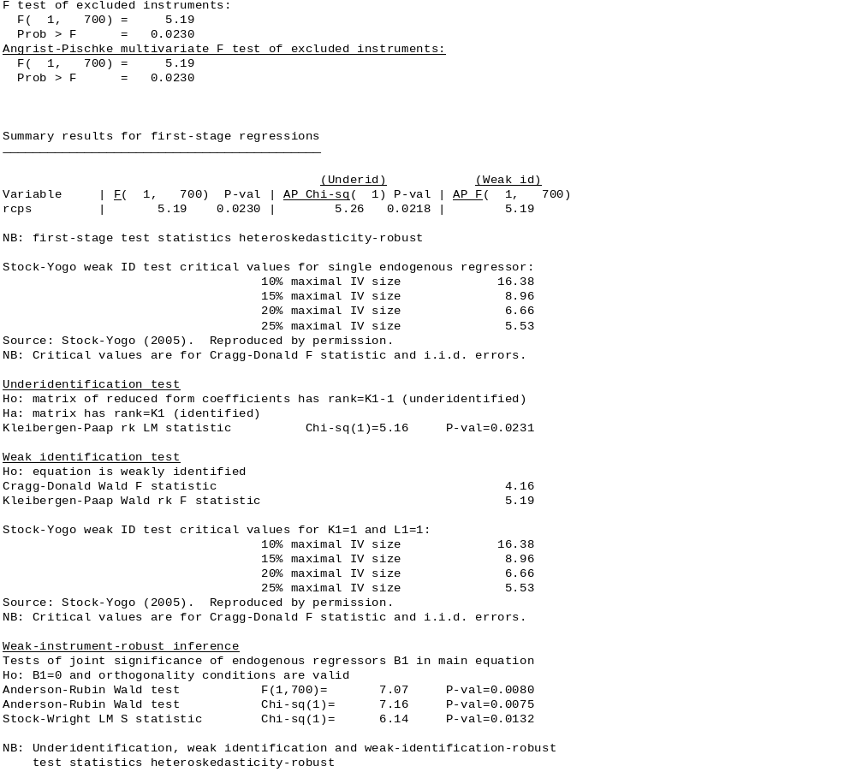
Second stage
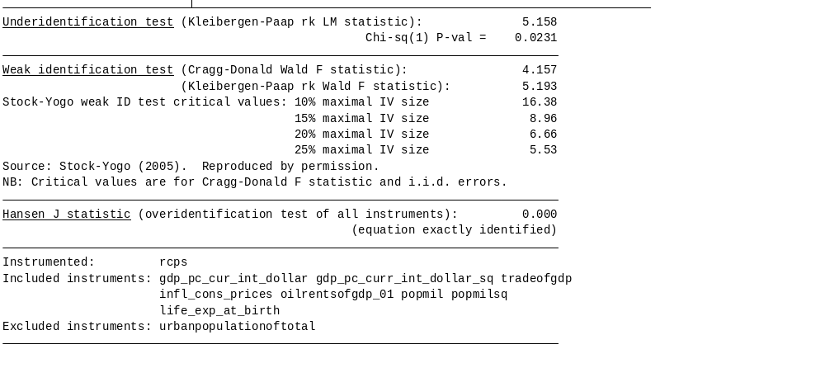

Associate Researcher, Wisconsin Center for Education Research, 1025 West Johnson Street, Suite 785, Madison, Wisconsin 53706, USA. Email: sahakyan@wisc.edu
Foreign Service Economist, U.S. Agency for International Development, 1300 Pennsylvania Ave NW, Washington DC, USA. Email:mnicholson@usaid.gov. The views expressed in here are those of the authors and do not reflect the opinions of the U.S. Agency for International Development.
Consultant, Appian Data Services, 4600 Adeline Street Suite 229, Emeryville, CA 94608, USA. Email:dave.kritzberg@gmail.com. The authors would like to thank Chris Rasmussen, Jeffrey Engels, Jim Launder, Casey Cagley, Gary Cook, Avraham Stoler, and seminar participants at the Analytical Skills Series in Monrovia, Liberia and at the 2012 Western Economic Association International conference in San Francisco, CA for the helpful comments and suggestions. We also thank Mark de Vries for providing the club soccer data.
Throughout this paper, we will use the terms “football” and “soccer” interchangeably.
In a very telling example, the best player of his generation and four-time FIFA/Balon d’Or Player of the Year (2009, 2010, 2011 and 2012) Lionel Messi left his home-town club in Argentina to play for FC Barcelona, because the local Argentine club was unable to afford his treatment for a growth hormone deficiency. Foer (2004) quotes the two-time Ballon d’Or winner Ronaldo (Brazil) saying “I will not go back to play in Brazil for any offer.” Ironically, he did go back to play in Brazil in 2009, but retired shortly after..
The index is created by summing up points and creating an annual ranking of all clubs by country, using only the points accumulated in international club competitions. Source: http://www.clubworldrankings.com/
The Yugoslavian national team in the early 1990s was pre-dominantly comprised of Red Star (Belgrade) players. The World-Cup-winning Spanish side of 2010 usually featured 7 starters from FC Barcelona. In related research, Baur and Lehmann (2007) question whether the cross-border mobility of soccer players influences the success of the national team with a focus on trade of players across borders. Their approach is based in Ricardian comparative advantage, and they use both FIFA rankings and the market value of domestic clubs.They find that both imports and exports help gains from trade.
See, as referenced below, Kuper and Szumanski (2009).
Coupled with evidence from previous studies on international sporting performance, an important factor in selecting the macroeconomic and resource variables used in the study was data availability. For example, while some other country-specific variables, such as per-capita health expenditures, size of government revenues or unemployment rates may have proven to be informative proxies for national economic performance, poor data quality precludes us from including them as additional controls.
www.fifa.com; www.clubworldrankings.com; data.worldbank.org/data-catalog/world-development-indicators
A PriceWaterhouseCoopers report (May 2010) providing an econometric analysis on world cup performance uses FIFA world rankings in OLS regressions for a set of 52 countries and fails to find a positive and statistically significant for GDP or Population.
Among others, Nicholson (2012) argues that the trade literature does itself a disservice with such a characterization. Data on exports plus imports relative to GDP does not necessarily reflect the “openness” of a country, given that countries like Canada and the United States maintain quite open trading regimes but do not have a high percentage of GDP in international trade due to the size of their domestic economies. For present purposes, however, this measure may accurately capture a proxy of exposure to international networks. Belgium and Netherlands, in the heart of Europe, are the standard bearers for trade as a percentage of GDP, and at the geo-political center of professional club soccer.
The Dutch influence on FC Barcelona’s and, consequently, Spain’s game is an example of such transfer and fusion of soccer know-how. While a better measure of “soccer-openness” could be constructed from annual player trade data and coaching databases, such data is not readily available.
Kuper and Szymanski (2009), Soccernomics, Chapter 7: “The Suburban Newsagents – City Sizes and Soccer Prizes”
Another finding is that temperature and population are insignificant in all of the specifications.
A reviewer has noted that Denmark’s victory in the 1992 Euro Cup far exceeds any comparable accomplishment by US Soccer. We emphasize that the FIFA rankings take into account all international competition, and acknowledge that although the glamorous tournaments such as Euro Cup and World Cup are appropriately weighted, they do not encompass the full universe of soccer competitions.
Time and country indices are dropped for ease of notation.
For example, Lionel Messi (supra note 3) plays for a club team in Spain and at the national level for Argentina. While his contributions in international competition accrue directly to Argentina, there may exist indirect “Messi effects” on the Spanish national team in which his weekly performance at the club level improves the quality of both his Barcelona teammates and his Madrid rivals (a selection of whom compete together under the Spanish flag.) For the econometric specification, we are not concerned about the magnitude of his indirect contributions so much as whether they exist at all.
Chapter 7 of Kuper and Szymanksi’s (2009) Soccernomics, “The Suburban Newsagents: City Sizes and Soccer Prizes”, discusses the historical dominance of provincial clubs in European soccer, and by extension global soccer. It’s Milan, not Rome; Munich, not Berlin; and Manchester, not London. (Madrid is cited as an exception due to a historical political anomaly as the only major club team in Western Europe to be run over a period of decades by a fascist political party and its leader Franco). Kuper and Szymanski explain the development on early industrialization and the influence of mobile labor. Industrialized countries with heavy urban populations indicate a cultural “preference” for soccer.
Statistical estimation of Equation 3 is performed using the module xtivreg2 in STATA 12, developed by Schaffer (2010). The module does not estimate a constant, and uses standard errors corrected for heteroskedasticity and autocorrelation.
First-stage regression results (not reported) confirm that a statistically significant (5%) and positive relationship exists between Urban Population and CLUB.
No statistical significance for any of the variables in other regional confederations was found, likely due to small sample sizes and model complexity. The exception was Africa, where GDP and population had the excepted signs (positive diminishing) and were statistically significant.
This finding also lends further support for the inclusion of “trade as a percentage of GDP” as an additional control.
For example, Chealsea’s win in the Champion’s League over Bayern Munich resulted in England’s advancement in CLUB by five positions, or an equivalent of five years of national life expectancy, with respect to the effect of these variables on international soccer success.

